 |  |  |  |  | Assignment brief NQF
Qualification |  |  | Level One/Level Two First Extended Certificate in Art and Design
Unit number and title |  |  | Unit 1: Introduction to Specialist Pathways in Art and Design
Learning aim(s) |  |  | Use specialist materials, techniques, equipment and processes in response to clients briefs  response to clients briefs  Learning aim B: Record formal elements within specialist pathways
Learner name |  |  |  |  |  |  |  | Assessor name
Date Issued | Hand in Deadline |  |  |  | Feedback to Learner Date (1) |  |  | Resubmission  Deadline |  |  |  | Feedback to Learner Date (2)
5th July 2019 | 27th August 2019
Assignment title |  | SUMMER PROJECT: Under the Sink/ Natural Forms
In this assessment you will have opportunities to provide evidence against the following criteria.
Criterion reference |  |  |  |  |  |  | Criteria Achieved |  |  | Assessment Comments
 |  |  |  |  |  |  | 1st Sub |  | Re-Sub
1B.2 Explore specialist techniques, materials, equipment and processes to record a minimum of at least two formal elements |  |  |  |  |  |  | Y N |  | Y N
2B.P2 Select and use specialist materials, equipment and processes to record a minimum of four formal elements to meet the requirements of specialist briefs |  |  |  |  |  |  | Y N |  | Y N
2B.M2 Competently select and use specialist materials, techniques and equipment to effectively record a diverse range of formal elements to meet the requirements of specialist briefs |  |  |  |  |  |  | Y N |  | Y N
2B.D2 Confidently develop and exploit the characteristics of specialist materials, techniques and processes to record a creative and diverse range of formal elements to meet the requirements of specialist briefs |  |  |  |  |  |  | Y N |  | Y N
Assessor Feedback to Learner for First Submission
Assessor Feedback to Learner for Resubmission (if required)
Submitted on time? YES/NO  Capable of upgrading? YES/NO  Work authenticated by learner and assessor? YES/NO  Resubmission Agreed: YES/NO |  |  |  |  |  |  |  | Lead IV Signature / Date
Assessor signature: I certify that the evidence submitted for this assignment is the learner’s own. I understand that false declaration is a form of malpractice. |  |  |  |  |  |  |  | First Submission & Date |  |  | Resubmission & Date
Learner Declaration: I certify that the work submitted is my own. I understand that false declaration is a form of malpractice.
Learner signature First Submission: Date:

Learner signature Resubmission : Date:
IV Sampled Y N |  |  |  | IV Name:  IV Signature: |  |  |  |  |  |  | Date:

Learning aims:
Learning aim B: Record formal elements within specialist pathways
Unit / Criteria reference | To achieve the criteria the evidence must show that the learner is able to: |  | Task no.
2B.P2 | Select and use specialist materials, equipment and processes to record a minimum of four formal elements to meet the requirements of specialist briefs |  | 1
2B.M2 | Competently select and use specialist materials, techniques and equipment to effectively record a diverse range of formal elements to meet the requirements of specialist briefs |  | 1
2B.D2 | Confidently develop and exploit the characteristics of specialist materials, techniques and processes to record a creative and diverse range of formal elements to meet the requirements of specialist briefs |  | 1
FOR NQF LEVEL 2 ONLY: If you have not achieved the Level 2 criteria, your work will be assessed to determine if the following Level 1 criteria have been met.
Unit / Criteria reference | To achieve the criteria you must show that you are able to:
1B.2 | Explore specialist techniques, materials, equipment and processes to record a minimum of at least two formal elements

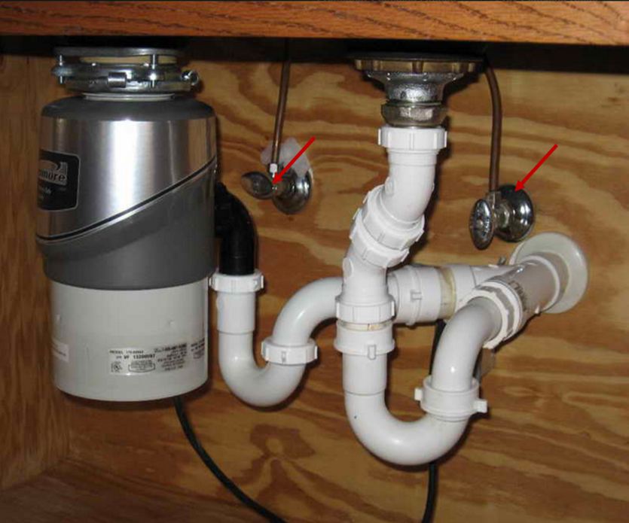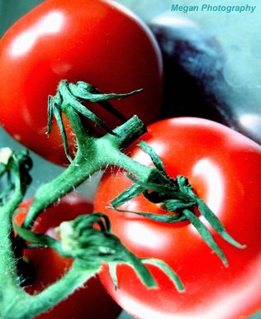

LEVEL ONE/TWO FIRST EXTENDED CERTIFICATE IN ART AND DESIGN
SUMMER PROJECT 2019
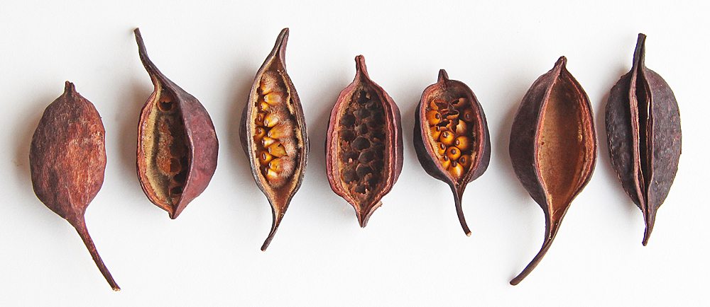
UNDER THE SINK
NATURAL FORMS
Assignment Brief:
Assignment title | SUMMER PROJECT: Under the Sink/Natural Forms
You will need to explore and research through making drawings of a wide collection of different surfaces and texture so that you can develop appropriate ideas.
The theme of your Summer Project is shared between UNDER THE SINK and NATURAL FORMS. We would like you to explore a range of drawing from these two themes.
You need to complete at least 20 pages in your book for the summer project and bring this work in to College on the 27th August for enrolment day.
UINDER THE SINK

At home look under a sink, take a photograph of the space and then create a range of different types of drawings from this space.

PRODUCE TEN DRAWINGS OR PAINTINGS OF WORK

This could include different views, textures, and pencil drawings of objects found under the sink.
You should also use colour. Try drawing using at least five of the techniques suggested on the list.
Pencil, Ink, Paint
Drawing using a toothbrush
Drawing using a sponge
Food dye to draw with
Collage and paint
Use your left hand or non drawing hand to draw with
Fix all of these in your book and then make some typed notes about what your favourites are and why and how you could develop the work further if you could.

NATURAL FORMS

Set up a collection of vegetable, plants or fruits on a table. Take a photograph and then create a range of different drawings/paintings from what you see. (not the photo)

PRODUCE TEN DRAWINGS OR PAINTINGS OF WORK

You could include drawings of individual objects or whole collections of objects. Try to make the following types of drawings:

Using only line to describe the shape of the objects

Using texture and pattern to describe the objects

Using cut out shapes and collage to describe the objects (how smooth or rough the object is)

Try drawing different scales and sizes to create an interesting view of the objects.

Put this work in your books and then type up your thoughts about the work you have completed

SOME WORDS EXPLAINED WHEN TALKING ABOUT ART AND VISUAL ELEMENTS IN WORK:

Line: a continuous mark that joins or surrounds
Tone: Describes the dark and light on an object
Texture: The surface quality of an object
Scale: The size of the marks created in drawing

THE MOST IMPORTANT THING IS TO HAVE FUN,TAKE RISKS AND CREATE LOTS OF IDEAS!!
Submission Guidelines
SUMMER PROJECT WORK IS ESSENTIAL TO GAIN ENTRY TO THE COURSE and
Must be completed and handed to the tutors at enrolment.
